ASAP Safety Manual

Peabody Tanners Little League Softball

Official Safety Guide for

Coaches, Volunteers and Parents

2024

Peabody Tanners Little League Softball #: 221-16-296769 Matthew Sumares
Safety Officer
617-869-3251
Contents
Peabody Tanners Little League Softball 3
Locations 4
PTLLS Safety Committee & Boards of Directors 5
PTLLS Code of Conduct 6
Volunteer Background Checks 8
PTLLS Safety Code 8
Storage Shed Procedures 10
Facilities 11
Catchers, Batters, Baserunners and Base Coaches 12
Asap. What Is It? 15
Checklist for Managers, Coaches, and Umpires 16
How to Prevent Injuries 18
Communicable Disease Procedures 21
Concussions 22
First Aid for Heat Issues 28
Recommendations for Coaches: 30
First Aid for Emergences 31
Giving CPR: 32
The Heimlich Maneuver 33
Lightning Facts and Safety Procedures 33
Concession Stand Information 34
KEEP IT CLEAN: CONCESSION STAND TIPS 36
Steps to Safe and Sanitary Food Service Events 36
Top Six Causes of Food Born Illness 37
Contract for Success 38
Accident Reporting Procedures 39
Director of Safety’s Responsibilities 39
Some Gentle Reminders 40
Volunteers & Adult Training 41
WHAT PARENTS SHOULD KNOW ABOUT LITTLE LEAGUE® INSURANCE 42
Forms & Attachments 44
COVID19 Safety Protocals…………………………………………………………………………………………………………………………………………………..45

Peabody Tanners Little League Softball 2024

At Peabody Tanners Little League Softball, safety of the players and volunteers is of first and foremost concern. Only through safe participation will everyone have an enjoyable Little League experience.

To that end, we have developed this Safety Manual to be used by all board members, managers, coaches, players and all other volunteers. It is the responsibility of all to become familiar with and utilize the information in this manual in all league activities.

Should anyone have any safety suggestions they wish to include in this manual, please contact the
Safety Director or any other member of the Board of Directors.

To assist the league with its requirement to ensure that we have properly trained managers and coaches, the league has and will conduct mandatory in-service training sessions.

On April 4, 2024 there will be a mandatory managers/coaches. At this meeting the safety manuals will be distributed, and first aid training will be reviewed.

We owe it to ourselves and to the children, to do our part to ensure that we have a safe successful season.

Thank you.

The Board of Directors, Peabody Tanners Little League Softball

Visit webpage for registration, updates and photos. http://www.peabodyllsoftball.org/

PTLLS FaceBook page

Let the Kids Play, but Play Safely

Locations

Burke School
127 Birch Street
Peabody, Massachusetts 01960

Higgins Middle School
85 Perkins Street
Peabody, Massachusetts 01960

Kiley School
21 Johnson Street
Peabody, Massachusetts 01960

Lalikos Park
Nancy Ave
Peabody, Massachusetts 01960

Lt Ross Park (Cy Tenney)
Johnson St
Peabody, Massachusetts 01960

McCarthy School
76 Lake Street
Peabody, Massachusetts 01960

Peabody Municipal Light Plant
1 Warren St Ext.
Peabody, Massachusetts 01960

Raddin Rd
Raddin Road
Peabody, Massachusetts 01960

Symphony Park
Symphony Rd
Peabody, Massachusetts

Click location to view with Google Maps

Peabody Police Department
(978) 531-1226

Peabody Fire Department
(978) 531-3444

MassGeneral for Children at North Shore Medical Center
57 Highland Avenue
Salem, MA 01970

Notes

PTLLS Safety Committee

Safety Official | Matthew Sumares | 617-869-3251
League President | Tawny Palmieri | 978-790-7272
League Vice President | Gary Palmieri | 978-790-7236
Coaching Coordinator | Molly Bonaventure | 617-774-7751

Board of Directors

Title | Name | Phone # | Email Address
President | Tawny Palmieri | 978-790-7272 | tannercitysports@gmail.com
Vice President | Gary Palmieri | 978-790-7236 | Garyp19@aol.com
Treasurer | Jennifer Brigandi | 978-771-9532 | Jen.brigandi@yahoo.com
Secretary | Keri Sousa | 978-750-1530 | Keridolphin25@comcast.net
Player Agent | Sean Creamer | 781-640-0486 | sjcreamer@comcast.net
Safety Officer/  Field Maintenance | Matthew Sumares | 617-869-3251 | Matthew.sumares@renaissanceins.com
Fundraising | Joe Cirame | 617-938-2251 | Gto500hp@hotmail.com
Coaching Coordinator | Molly Bonaventurae | 617-774-7751 | Molly.easterday@yahoo.com
League Information | Michael Tango | 978-818-9209 | Michael.tango10@gmail.com
Equipment Manager | Dennis Mills | 781-484-8527 | Kso1carpentry@gmail.com

Notes & Numbers

PTLLS Code of Conduct

- Speed Limit 5 mph in roadways and parking lots while attending any Peabody Tanners Little
League Softball function. Watch for small children around parked cars.

- No Alcohol allowed in any parking lot, field, or common areas within a Peabody Tanners
Little League Softball complex.

- No Playing in parking lots at any time.

- No Playing on and around lawn equipment.

- Use Cross walks when crossing roadways. Always be alert for traffic.

- No Profanity please.

- No Swinging Bats or throwing balls at any time within the walkways and common areas of a
Peabody Tanners Little League Softball complex.

- No throwing balls against dugouts or against backstop. Catchers must be used for all batting practice sessions.

- No throwing rocks

- No horse play in walkways at any time.

- No climbing fences.

- No pets are permitted at Peabody Tanners Little League Softball games or practices.

- Only a player on the field and at bat, may swing a bat (Age 5 - 12). Be Alert of area around you in the on-deck position.

- Observe all posted signs. Players and spectators should always be Alert for Foul Balls and Errant Throws.

- During game, players must always remain in the dugout area in an orderly fashion.

- After each game, each team must clean up trash in dugout and around stands.

- All gates to the field must always remain closed. After players have entered or left the playing field, gates should be closed and secured.

- No children under the age of 16 are to be permitted in the Snack Bars.

Failure to comply with the above may result in expulsion from the
Peabody Tanners Little League Softball fields or complex.

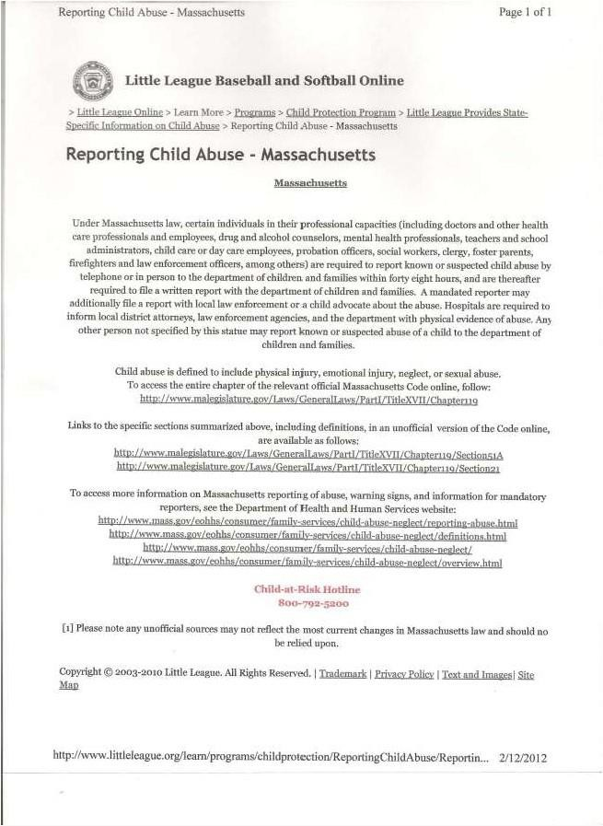

Reporting Child Abuse

Volunteer Background Checks

All people who wish to volunteer for a position of manager, coach, board member and any others who provide regular services to the league and/or have repetitive access to or contact with players or teams within the league must fill out a “Little League Volunteer Application” and a “MA CORI Request Form”, as well as provide a government-issued identification card for ID verification. Peabody Tanners Little League Softball will be conducting a national background check through First Advantage, as well as a Massachusetts Criminal Offender Record Information request on all volunteers.

Anyone refusing to fill out these forms or provide necessary information is ineligible to participate in any capacity.

These confidential records will be retained by the league president for the year of service.

PTLLS Safety Code

Dedicated to Injury Prevention

- Responsibility for Safety procedures should be that of an adult member of Peabody Tanners Little
League Softball

- Arrangements should be made in advance of all games and practices for emergency medical services

- Managers, coaches and umpires should have training in first aid. First-aid kits are issued to each team manager and are located at each Field Box.

- No games or practices should be held when weather or field conditions are not good, particularly when lighting is inadequate.

- Coaches will inspect playing field for holes, damage, stones, glass and other foreign objects. Report any issues with the Safety Officer ASAP.

- Safety Officer will frequently inspect playing field for holes, damage, stones, glass and other foreign objects.

- All team equipment should be stored within the team dugout, or behind screens, and not within the area defined by the umpires as “in play”.

- Only players, managers, coaches, and umpires are permitted on the playing field or in the dugout during games and practice sessions.
- Responsibility for keeping bats and loose equipment off the field of play should be that of a player
assigned for this purpose or the team’s manager and coaches.

- Procedure should be established for retrieving foul balls batted out of playing area.

- During practice and games, all players should be alert and watching the batter on each pitch.

- During warm-up drills players should be spaced so that no one is endangered by wild throws or missed catches.

- All pre-game warm-ups should be performed within the confines of the playing field and not within areas that are frequented by, and thus endanger spectators (i.e., playing catch, pepper, swinging bats, etc.)

- Equipment should be inspected regularly for the condition of the equipment as well as for proper fit.

- Batters must wear Little League approved protective helmets during batting practice and games.

- Catcher must wear catcher’s helmet, mask, throat guard, chest protector and shin guards at all times for all practices and games. NO EXCEPTIONS.

- Managers should encourage all male players to wear protective cups and supporters for practices and games.

- Except when runner is returning to a base, headfirst slides are not permitted.

- During sliding practice, bases should not be strapped down or anchored.

- At no time should “horse play” be permitted on the playing field

- Parents of players who wear glasses should be encouraged to provide “safety glasses”

- Player must not wear watches, rings, pins or metallic items during games and practices.

- The Catcher must wear catcher’s helmet and mask with a throat guard in warming up pitchers. This applies between innings and in the bull-pen during a game and also during practices

- On-deck batters are not permitted (except in Juniors Division).

- Managers and Coaches must follow the Pitch Count regulation where applicable, 85 pitches for 11-12year olds and 75 pitches for 9-10 year olds and 50 pitches for 7-8 year olds.

See a need to add to the safety code? Contact:
Matthew Sumares, Safety Officer 617-869-3251

Safety Issues or Accidents, must be reported immediately
to the Safety Officer, Coach or PTLLS Official.

Storage Shed Procedures

The following applies to all of the storage sheds or field boxes used by Peabody Tanners Little
League Softball and apply to anyone who has been issued a key to use those sheds or field boxes.

· All individuals with keys to the Peabody Tanners Little League Softball equipment sheds or field boxes (i.e., Managers, Umpires, etc.) are aware of their responsibilities for the orderly and safe storage of rakes, shovels, bases, etc.

· Before you use any machinery located in the shed or field boxes (i.e., lawn mowers, weed whackers, lights, scoreboards, public address systems, etc.) please locate and read the written operating procedures for that equipment.

· All chemicals or organic materials stored in Peabody Tanners Little League Softball sheds or field boxes shall be properly marked and labeled as to its contents.

· All chemicals or organic materials (i.e., lime, fertilizer, etc.) stored within these equipment sheds will be separated from the areas used to store machinery and gardening equipment (i.e., rakes, shovels, etc.) to minimize the risk of puncturing storage containers.

· Any witnessed “loose” chemicals or organic materials within these sheds should be cleaned up
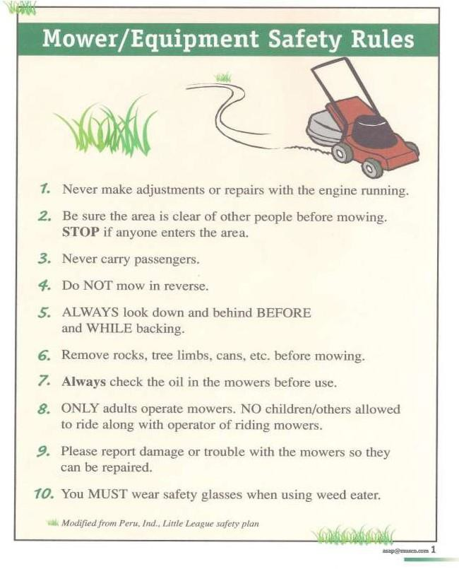
and disposed of as soon possible to prevent accidental poisoning.

Equipment Safety Rules

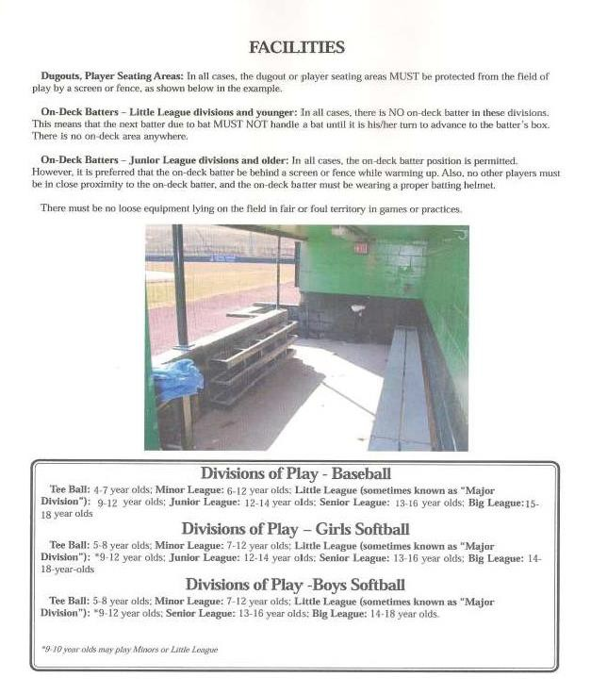
Facilities

Catchers, Batters, Baserunners and Base Coaches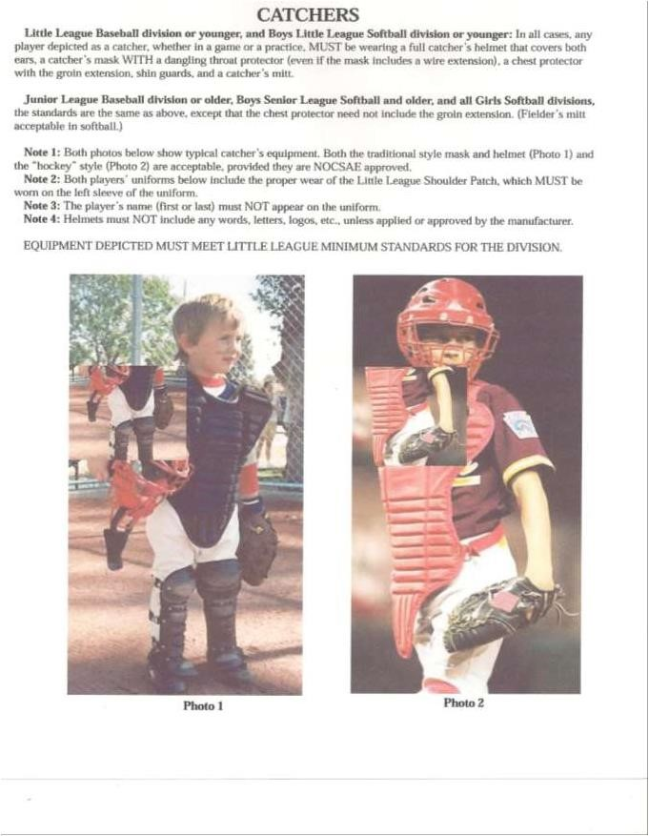
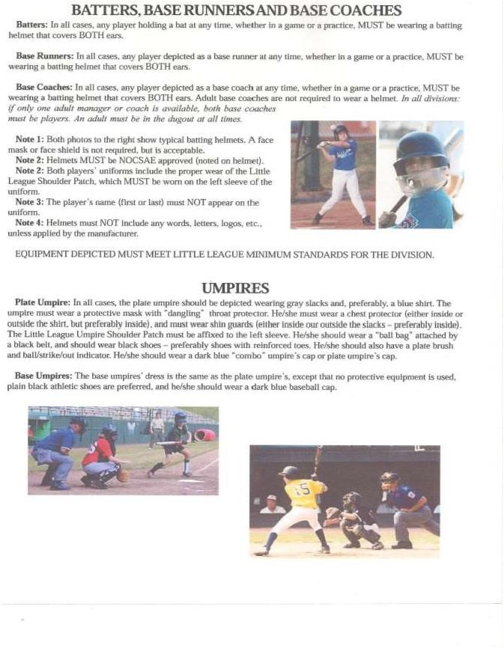

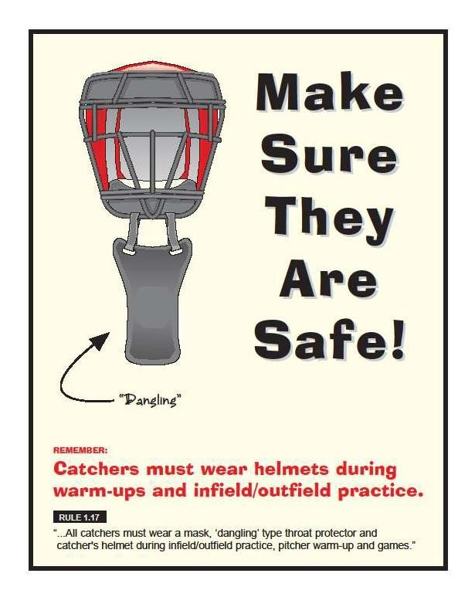

ASAP. What Is It?

In 1995, ASAP (A Safety Awareness Program) was introduced with the goal of re- emphasizing the position of Safety Officer “to create awareness, through education and information, of the opportunities to provide a safer environment for kids and all participants of Little League Baseball”.

This manual is offered as a tool to place some important information at manager’s and coach’s finger
tips.

Do ...
Some Important Do’s and Don’ts

· Reassure and aid children who are injured, frightened, or lost

· Provide, or assist in obtaining, medical attention for those who require it.

· Know your limitations.

· Carry your first-aid kit to all games and practices

· Keep your “Prevention and Emergency Management of Little League Baseball and Softball Injuries”

booklet with your first-aid kit.

· Assist those who require medical attention - and when administering aid, remember to ...

· LOOK for signs of injury (Blood, Black-and-blue deformity of joint etc.).

· LISTEN to the injured describe what happened and what hurts if conscious. Before questioning, you may have to calm and soothe an excited child.
· FEEL gently and carefully the injured area for signs of swelling or grating of broken bone.

· Have your players’ Medical Clearance Forms with you at all games and practices.

· Decide to have a cellular phone available when your game or practice is at a facility that does not have any public phone

Don’t ...

· Administer any medications

· Provide any food or beverages (other than water)

· Hesitate in giving aid when needed

· Be afraid to ask for help if you’re not sure of the proper procedures (i.e., CPR, etc.)

· Transport injured individuals except in extreme emergencies

· Leave an unattended child at a practice or game

· Hesitate to report any present or potential safety hazard to the Safety Officer immediately.

Checklist for Managers, Coaches, and Umpires

Good Procedures to Implement

A. Safe Playing Areas
Regular safety inspections of all fields, (practice and game), structures, and dugouts, is the best way to eliminate conditions that cause accidents. Managers, coaches, and umpires should routinely check playing area for:
1. Holes, damage, rough or uneven spots, slippery areas, and long grass
2. Glass, rocks, foreign objects
3. Damage to screens or fences, including holes, sharp edges, or loose edges
4. Unsafe conditions around backstop, pitcher’s mound, or warning track 5. Proper attire by the
catcher at all times, including in the bull pens and in between innings

B. Safe Equipment
All equipment shall be inspected before each use. Regular safety inspection of equipment is essential. Managers, coaches, and umpires should:
1. Be sure all equipment is LL approved.
2. Inspect all bats, helmets, and other equipment on a regular basis. Dispose of unsafe equipment properly.
3. Keep loose equipment stored properly
4. Have all players remove all personal jewelry
5. Parents should be encouraged to provide safety glasses for players who wear glasses
6. Repair or replace defective equipment

C. Safe Procedures
Managers and coaches must:
1. Have all players’ medical release forms with you at every practice and game
2. Have a first aid kit with you all practices and games
3. Have access to a telephone in case of emergencies
4. Know where the closest emergency shelter is in case of severe weather
5. Ensure warm-up procedures have been completed by all players
6. Stress the importance of paying attention, no “horse playing allowed”
7. Instruct the players on proper fundamentals of the game to ensure safe participation
8. Each practice should have at least 2 coaches in case of an emergency

D. Weather Conditions
Before the Storm
1. Check the weather forecast before leaving for a game or practice
2. Watch for signs of an approaching storm
3. Postpone outdoor activities if storms are imminent

Approaching Thunderstorm
1. Take caution when you hear thunder. If you hear thunder, you are close enough to get struck by lightning. During a game, the umpire will clear the field in the event of an approaching storm.
2. Move to a safe environment immediately. Do not go under a tree or stay in the dugout.
3. If lightening is occurring and there is not sturdy shelter near, get inside a hard top automobile and keep the window up.
4. Stay away from water, metal pipes, and telephone lines.
5. Unplug appliances not necessary for obtaining weather information. Avoid the telephone except for emergency use only.
6. Turn off air conditioners.

If caught outdoors & no shelter exists
1. Find a low spot away from trees, fences, light poles, and flagpoles. Make sure the site you pick is not prone to flooding.
2. If in the woods, take cover under shorter trees.
3. If you feel your skin begin to tingle
or your hair feels like it’s standing on end, squat low to the ground, balancing on the balls of your feet. Make yourself the smallest possible target, tuck your head between your legs, and minimize your contact with the ground.

What to do if someone is struck by lightning
1. The person who has been struck will carry no electrical charge; therefore, they are safe to touch.
2. Call 9-1-1 as soon as possible for help.
3. Check for burns to the body.
4. Give first aid as needed.
5. If breathing and/or heartbeat have stopped, perform CPR until EMS arrives.
6. Contact the league Safety Officer or President ASAP.

Safety Issues or Accidents, must be reported immediately
to the Safety Officer, Coach or PTLLS Official.

How to Prevent Injuries

Managers and coaches should consider the following to prevent injuries:
1. Check medical release form for health concerns and medications.
2. Proper maintenance of the playing site (game and practice facilities).
3. Play close attention to playing conditions (heat and humidity as well as severe weather).
4. Make sure players know basics of good nutrition (especially water replacement on hot days).
5. Proper athletic conditioning (stretching, strengthening, and endurance, as well as agility and coordination drills.
6. Avoid over use (pay special attention to activities outside of Little League, to allow rest to avoid over-use injuries.
7. Consistent and proper use of all protective equipment.
8. Close supervision and organization of warm-ups, practices and games.
9. Careful compliance with all Little League rules, especially those having to do with safety.

Evaluating Fresh Injuries
In evaluating fresh injuries, remember the three types of motion:
1. Active Motion – Player is able to move the part themselves,
2. Active Assistance Motion – Player is able to move with a little help from you; (watch the warning signs like the player telling you it hurts to move), and
3. Passive Motion – the player’s injured part is moved by someone else; be especially cautious with passive motion that you do not make the injury worse.

Look for disability (the player can’t use the injured part); this is the most serious injury. If a player sprains his/her ankle, but can still limp around, it may be mild or moderate; if he/she can’t get up, it is probably severe. Look for swelling, the more immediate and large the swelling, the more serious the injury, because swelling on outside means bleeding on inside. Also, a noticeable deformity means a serious injury. If the body part doesn’t look the way it did before the accident, something’s wrong. Consider unconsciousness or an eye injury as a serious situation, in the category of severe injuries, until you are assured otherwise by a medical professional.

Carefully evaluate all injuries and ensure the child does not require professional care. It’s not worth risking a child’s health just to continue the game.

Safety Issues or Accidents, must be reported immediately
to the Safety Officer, Coach or PTLLS Official.

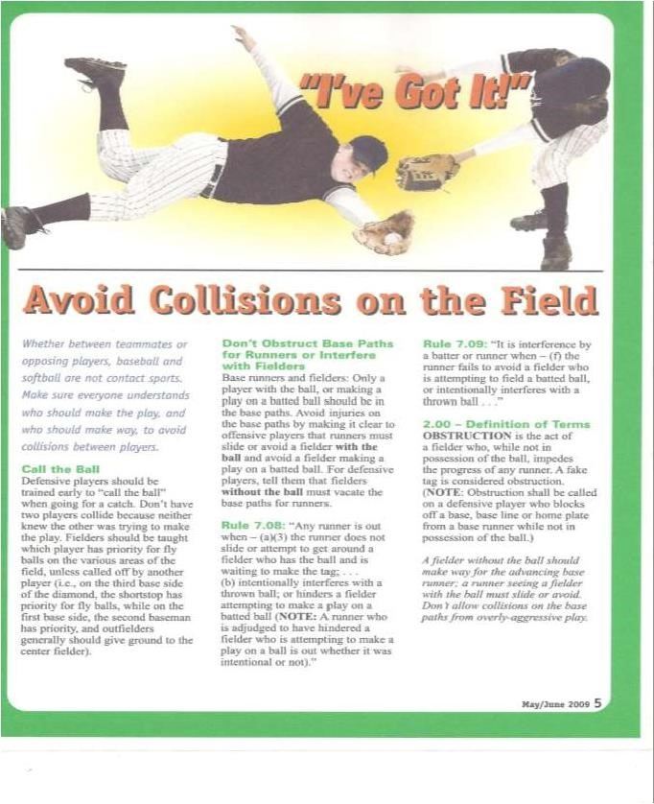

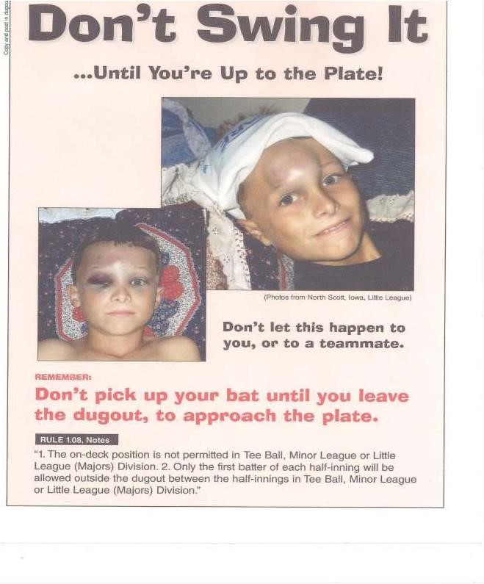

Communicable Disease Procedures

While risk of one athlete infecting another with HIV/AIDS during competition is close to non-existent, there is a remote risk that other blood born infectious diseases can be transmitted.
For example, Hepatitis B can be present in blood as well as in other body fluids.

Procedures for reducing the potential for transmission of these infectious agents should include, but not be limited to, the following:

1. The bleeding must be stopped, the open wound covered and if there is an excessive amount of blood on the uniform it must be changed before the athlete may participate.

2. Routine use of gloves or other precautions to prevent skin and mucous-membrane exposure when contact with blood or other body fluids is anticipated.

3. Immediately wash hands and other skin surfaces if contaminated (in contact) with blood or other body fluids. Wash hands immediately after removing gloves.

4. Clean all contaminated surfaces and equipment with an appropriate disinfectant before competition resumes.

5. Practice proper disposal procedures to prevent injuries caused by needles, scalpels and other sharp instruments or devices.

6. Although saliva has not been implicated in HIV transmission, to minimize the need for emergency mouth-to-mouth resuscitation, mouthpieces, resuscitation bags, or other ventilation devices should be available for use.

7. Athletic trainers/coaches with bleeding or oozing skin conditions should refrain from all direct athletic care until the condition resolves.

8. Contaminated towels should be properly disposed of or disinfected.

9. Follow acceptable guidelines in the immediate control of bleeding and when handling bloody dressings, mouth guards and other articles containing body fluids.

Concussions
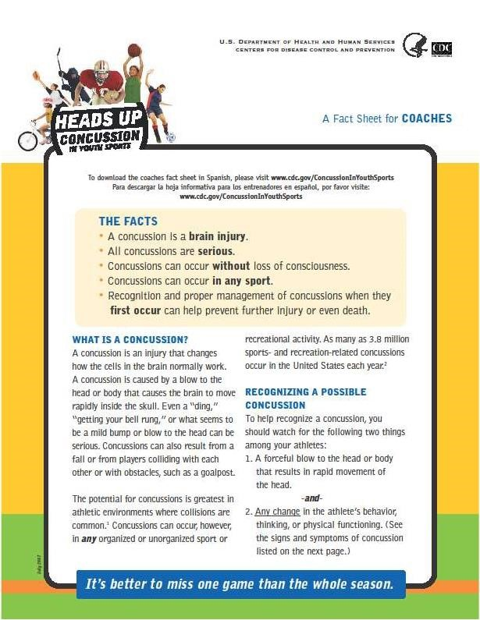

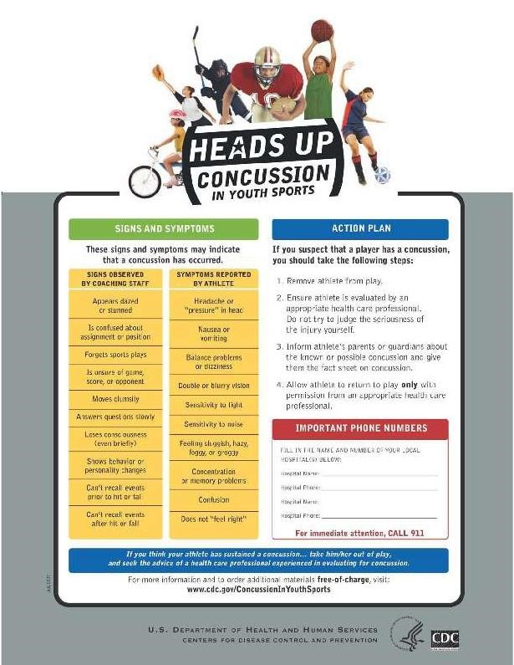

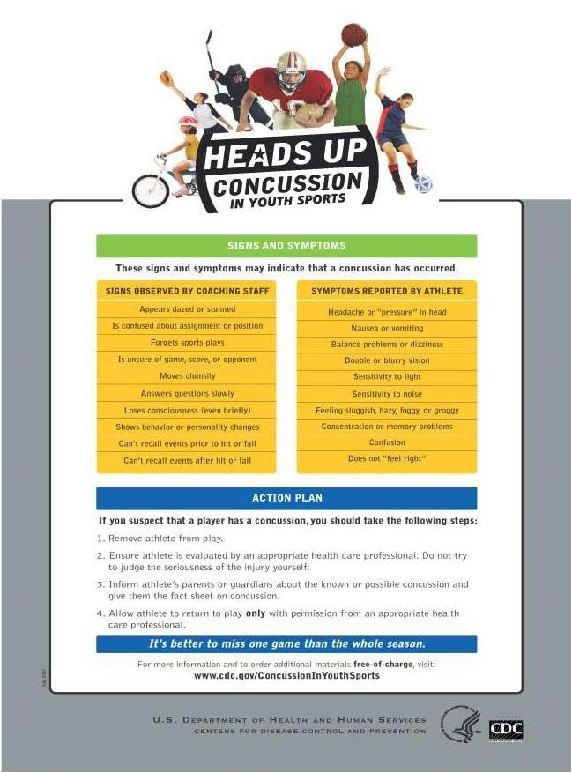

First Aid for Heat Issues

Heat Stroke
Heat stroke is the most serious heat-related disorder. It occurs when the body becomes unable to control its temperature: the body's temperature rises rapidly, the sweating mechanism fails, and the body is unable to cool down. When heat stroke occurs, the body temperature can rise to 106 degrees Fahrenheit or higher within 10 to 15 minutes. Heat stroke can cause death or permanent disability if emergency treatment is not given.

Symptoms
Symptoms of heat stroke include:
• Hot, dry skin or profuse sweating
• Hallucinations
• Chills
• Throbbing headache
• High body temperature
• Confusion/dizziness
• Slurred speech

First Aid
Take the following steps to treat a player with heat stroke:
• Call 911 and notify their parent.
• Move the sick player to a cool shaded area.
• Cool the player using methods such as:
• Soaking their clothes with water.
• Spraying, sponging, or showering them with water. • Fanning their body.

Heat Exhaustion
Heat exhaustion is the body's response to an excessive loss of the water and salt, usually through excessive sweating.

Symptoms
Symptoms of heat exhaustion include:
• Heavy sweating
• Extreme weakness or fatigue
• Dizziness, confusion
• Nausea
• Clammy, moist skin
• Pale or flushed complexion
• Muscle cramps
• Slightly elevated body temperature
• Fast and shallow breathing

First Aid
Treat a Player suffering from heat exhaustion with the following:
• Have them rest in a cool, shaded or air-conditioned area.
• Have them drink plenty of water or other cool beverages.
• Have them take a cool shower, bath, or sponge bath.

Heat Syncope
Heat syncope is a fainting (syncope) episode or dizziness that usually occurs with prolonged standing or sudden rising from a sitting or lying position. Factors that may contribute to heat syncope include dehydration
and lack of acclimatization.

Symptoms
Symptoms of heat syncope include:
• Light-headedness
• Dizziness
• Fainting

First Aid
Players with heat syncope should:
• Sit or lie down in a cool place when they begin to feel symptoms.
• Slowly drink water, clear juice, or a sports beverage.

Heat Cramps
Heat cramps usually affect players who sweat a lot during strenuous activity. This sweating depletes the body's salt and moisture levels. Low salt levels in muscles causes painful cramps. Heat cramps may also be a
symptom of heat exhaustion.

Symptoms
Muscle pain or spasms usually in the abdomen, arms, or legs.

First Aid
Players with heat cramps should:
• Stop all activity, and sit in a cool place.
• Drink clear juice or a sports beverage.
• Do not return to activities for a few hours after the cramps subside because further exertion may lead to heat exhaustion or heat stroke.
• Seek medical attention if any of the following apply:
• the player has heart problems.
• the player is on a low-sodium diet.
• the cramps do not subside within one hour.

Heat Rash
Heat rash is a skin irritation caused by excessive sweating during hot, humid weather.

Symptoms
Symptoms of heat rash include:
• Heat rash looks like a red cluster of pimples or small blisters.
• It is more likely to occur on the neck and upper chest, in the groin, under the breasts, and in elbow creases.

First Aid
Players experiencing heat rash should:
• Try to work in a cooler, less humid environment when possible.
• Keep the affected area dry.
• Dusting powder may be used to increase comfort.

Recommendations for Coaches:

Coaches should take the following steps to protect players from heat stress:
• Schedule practices for the cooler part of the day.
• Reduce the physical demands of players.
• Provide cool water or liquids to players.
• Avoid drinks with caffeine or large amounts of sugar.
• Provide rest periods with water breaks.
• Provide cool areas for use during break periods.
• Monitor players who are at risk of heat stress.
• Provide heat stress training that includes information about:
o Player risk o Prevention o Symptoms
o the importance of monitoring yourself and players for symptoms o Treatment
o Personal protective equipment

First Aid for Emergences

Care For Sudden Illness
· Keep the victim from getting chilled or overheated.
· Do not give anything to eat or drink unless the victim is fully conscious.
· Reassure the victim.
· Call 9-1-1
· Watch for changes in consciousness and breathing.
· Help the victim rest comfortably.

If the victim:
Vomits --Place the victim on his or her side.
Faints --Position him or her on the back and elevate the legs 8 to 10 inches if you do not suspect a head or back injury.
Has a diabetic emergency --Give the victim some form of sugar..
Has a seizure --Do not hold or restrain the person or place anything between the victim's teeth.
Remove any nearby objects that might cause injury. Cushion the victim's head using folded clothing or a small pillow.

Caring for Shock:
Shock is likely to develop in any serious injury or illness. Signals of shock include: Restlessness or irritability - Rapid breathing - Altered consciousness - Rapid pulse – Pale, cool, moist skin

Caring for shock involves the following steps:
· Have the victim lie down. Helping the victim rest comfortably is important because pain can intensify the body's stress and accelerate the progression of shock. Keep victim still and
seek professional medical help immediately.

Giving CPR:

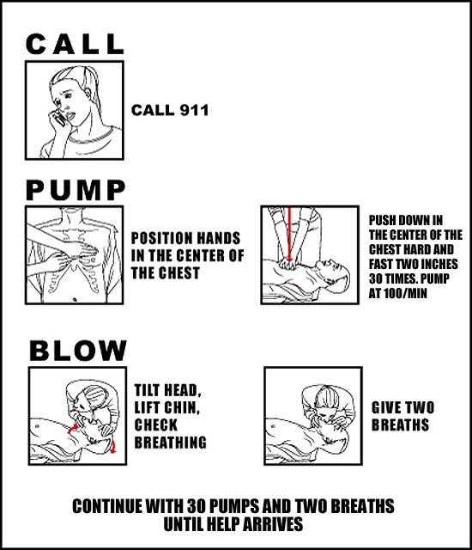
· Position victim on back on a flat surface.
· Position yourself so that you can give rescue breaths and chest compressions without having to move (usually to one side of the victim).
· Find hand position on the breastbone. (See
figure)
· Position shoulders over hands for proper leverage.
· Compress chest 30 times.
· With victim's head tilted back, and chin lifted, pinch the nose shut.
· Give two (2) slow breaths into victim’s mouth (1 for small children).
· Breathe in until chest rises slightly.
· Do 3 more sets of 30 compressions and 2 breaths. (For small children, 5 compressions and
1 breath)
· Recheck pulse and breathing for about 5 seconds.
· If there is no pulse, continue sets of compressions (30/2)
· When giving CPR to small children, use only one hand for compressions.

When To Stop CPR:
· If another trained person takes over for you
· If paramedics arrive
If you are exhausted and unable to continue properly
· If the scene becomes unsafe

Here's advice from the American Heart Association:

Untrained. If you're not trained in CPR, then provide hands-only CPR. That means uninterrupted chest compressions of 100 to 120 a minute until paramedics arrive (described in more detail below). You don't need to try rescue breathing.

Trained and ready to go. If you're well-trained and confident in your ability, check to see if there is a pulse and breathing. If there is no breathing or a pulse within 10 seconds, begin chest compressions. Start CPR with 30 chest compressions before giving two rescue breaths.

Trained but rusty. If you've previously received CPR training but you're not confident in your abilities, then just do chest compressions at a rate of 100 to 120 a minute. (Details described below.)

The Heimlich Maneuver

The Heimlich Maneuver is an emergency method of removing food or foreign objects from the airway to prevent suffocation.
· When approaching a choking person, one who is still conscious, ask: “Can you cough? Can you speak?”
· If the person can speak or cough, do not perform the Heimlich Maneuver or pat them on the back.
· Encourage them to cough.

To perform the Heimlich:
· Grasp the choking person from behind;
· Place a fist, thumb side in, just below the person’s breastbone (sternum), but above the naval;
· Wrap second hand firmly over this fist;
· Pull your fist firmly and abruptly into the top of the stomach. It is important to keep the fist below the chest bones and above the naval (belly button). The procedure should be repeated until the airway is free from obstruction or until the person who is choking loses consciousness (goes limp). These will be violent thrusts, as many times as it takes.

For a child:
· Place your hands at the top of the pelvis;
· Put the thumb of you hand at the pelvis line;
· Put the other hand on top of the first hand;
· Pull forcefully back as many times as needed to get object out or the child becomes limp.

Most individuals are fine after the object is removed from the airway. However, occasionally the object will go into one of the lungs. If there is a possibility that the foreign object was not expelled, medical care should be sought.

If the object cannot be removed completely by performing the Heimlich, immediate medical care should be sought by calling 911 or going to the local emergency room.

Safety Issues or Accidents, must be reported immediately
to the Safety Officer, Coach or PTLLS Official.

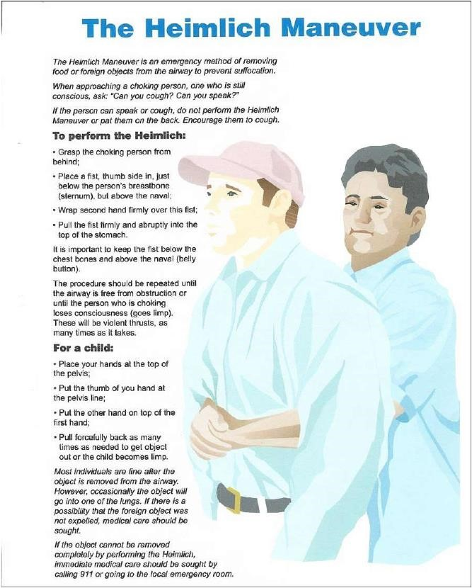

Lightning Facts and Safety Procedures
WHEN YOU HEAR IT - CLEAR IT WHEN YOU SEE IT - FLEE IT Consider the following facts:
· The average lightning strike is 6 - 8 miles long.
· The average thunderstorm is 6 -10 miles wide and travels at a rate of 25 miles per hour.
· Once the leading edge of a thunderstorm approaches to within 10 miles, you are at immediate risk due to the
possibility of lightning strikes coming from the storm’s overhanging anvil cloud (for example, the lightning that
injured 13 people during a concert at RFK one summer occurred while it was sunny and dry).
· On the average, thunder can only be heard over a distance of 3 - 4 miles, depending on humidity, terrain, and other factors. This means that by the time you hear the thunder, you are already in the risk area for lightning
strikes.

“Flash-Bang” Method
One way of determining how close a recent lightning strike is to you is called the “flash-bang” method. With the “flashbang” method, a person counts the number of seconds between the sight of a lightning strike and the sound of thunder that follows it. Halt-play and evacuation should be called for when the count between the lightning flash and the sound of its thunder is 15 seconds or less.

Rule of Thumb
The ultimate truth about lightning is that it is unpredictable and cannot be prevented. Therefore, a manager, coach, or umpire who feels threatened by an approaching storm should stop play and get the kids to safety.
When in doubt, the following rule of thumb should be applied:

Where to Go?
No place is absolutely safe from the lightning threat, but some places are safer than others. Large enclosed shelters (substantially constructed buildings) are the safest. For the majority of participants, the best area for
them to seek shelter is in a fully enclosed metal vehicle with the windows rolled up. If you are stranded in an open area and cannot get to shelter in a car, put your feet together, crouch down, and put your hands over
your ears (to try and prevent eardrum damage).

Where NOT to Go!!
Avoid high places and open fields, isolated trees, unprotected gazebos, rain or picnic shelters, dugouts, flagpoles, light poles, bleachers (metal or wood), metal fences, and water

Concession Stand Information
The following information is intended to help you run a healthful concession stand. Following these simple guidelines will help minimize the risk of foodborne illness.

1. Menu. Keep your menu simple, and keep potentially hazardous foods (meats, eggs, dairy products, protein salads, cut fruits and vegetables, etc.) to a minimum. Avoid using precooked foods or leftovers. Use only foods from approved sources, avoiding foods that have been prepared at home. Complete control over your food, from source to service, is the key to safe, sanitary food service.

2. Cooking. Use a food thermometer to check on cooking and holding temperatures of potentially hazardous foods. All potentially hazardous foods should be kept at 41º F or below (if cold) or 140º F or above (if hot). Ground beef and ground pork products should be cooked to an internal temperature of 155º F, poultry parts should be cooked to
165º F. Most foodborne illnesses from temporary events can be traced back to lapses in temperature control.

3. Reheating. Rapidly reheat potentially hazardous foods to 165º F. Do not attempt to heat foods in crock pots, steam tables, over Sterno units or other holding devices. Slow-cooking mechanisms may activate bacteria and never reach killing temperatures.

4. Cooling and Cold Storage. Foods that require refrigeration must be cooled to 41º F as quickly as possible and held
at that temperature until ready to serve. To cool foods down quickly, use an ice water bath (60% ice to 40% water), stirring the product frequently, or place the food in shallow pans no more than 4 inches in depth and refrigerate. Pans should not be stored one atop the other and lids should be off or ajar until the food is completely cooled. Check the temperature periodically to see if the food is cooling properly. Allowing hazardous foods to remain unrefrigerated for too long has been the number ONE cause of foodborne illness.

5. Hand Washing. Frequent and thorough hand washing remains the first line of defense in preventing foodborne disease. The use of disposable gloves can provide an additional barrier to contamination, but they are no substitute for hand washing!

6. Health and Hygiene. Only healthy workers should prepare and serve food. Anyone who shows symptoms of disease (cramps, nausea, fever, vomiting, diarrhea, jaundice, etc.) or who has open sores or infected cuts on the hands should not be allowed in the food concession area. Workers should wear clean outer garments and should not smoke in the concession area. The use of hair restraints is recommended to prevent hair ending up in food products.

7. Food Handling. Avoid hand contact with raw, ready-to eat foods and food contact surfaces. Use an acceptable dispensing utensil to serve food. Touching food with bare hands can transfer germs to food.

8. Dishwashing. Use disposable utensils for food service. Keep your hands away from food contact surfaces, and never reuse disposable dishware. Ideally, dishes and utensils should be washed in a four-step process:
1. Washing in hot soapy water; | 2. Rinsing in clean water;
3. Chemical or heat sanitizing; and | 4 Air drying.

9. Ice. Ice used to cool cans/bottles should not be used in cup beverages and should be stored separately. Use a scoop to dispense ice; never use the hands. Ice can become contaminated with bacteria and viruses and cause foodborne illness.

10. Wiping Cloths. Rinse and store your wiping cloths in a bucket of sanitizer (example: 1 gallon of water and 1.2 teaspoon of chlorine bleach). Change the solution every two hours. Well sanitized work surfaces prevent cross contamination and discourage flies.

11. Insect Control and Waste. Keep foods covered to protect them from insects. Store pesticides away from foods.
Place garbage and paper wastes in a refuse container with a tight-fitting lid. Dispose of wastewater in an approved method (do not dump it outside). All water used should be potable water from an approved source.

12. Food Storage and Cleanliness. Keep foods stored off the floor at least six inches. After your event is finished, clean the concession area and discard unusable food

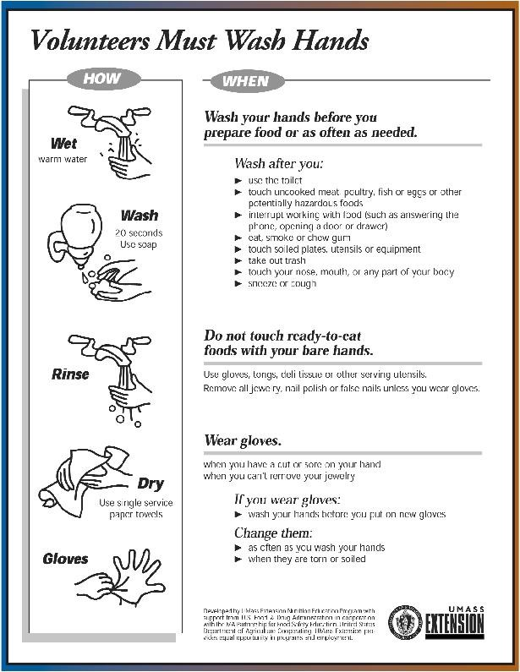

KEEP IT CLEAN: CONCESSION STAND TIPS

Steps to Safe and Sanitary Food Service Events

Clean Hands for Clean Foods-
Since the staff at concession stands may not be professional food workers, it is important that they be thoroughly instructed in the proper method of washing their hands. The following may serve as a guide:

· Use soap and warm water.
· Rub your hands vigorously as you wash them.
· Wash all surfaces including the backs of hands, wrists, between fingers and under fingernails.
· Rinse your hands well.
· Dry hands with a paper towel.
· Turn off the water using a paper towel, instead of your bare hands.

Wash your hands in this fashion before you begin work and frequently during the day, especially after performing any of these activities:
· After touching bare human body parts other than clean hands and clean, exposed portions of arms.
· After using the restroom.
· After caring for or handling animals.
· After coughing, sneezing, using a handkerchief or disposable tissue.
· After handling soiled surfaces, equipment or utensils.
· After drinking, using tobacco, or eating.
· During food preparation, as often as necessary to remove soil and contamination and to prevent cross-contamination when changing tasks.
· When switching between working with raw food and working with ready-to-eat food.
· Directly before touching ready-to-eat food or food contact surfaces. · After engaging in activities that contaminate hands.

Top Six Causes of Food Born Illness
The US Centers for Disease Control and Prevention (CDC) list these circumstances as the most likely to lead to illness. Check this list to make sure your concession stand has covered these common causes of food born illness.
· Inadequate cooling and cold holding.
· Preparing food too far in advance for service.
· Poor personal hygiene and infected personnel.
· Inadequate reheating.
· Inadequate hot holding.
· Contaminated raw foods and ingredients.

Contract for Success

What do I expect from my players?

· to be on time for all practices and games.
· to always do their best whether in the field or on the bench.
· to be cooperative at all times and share team duties.
· to respect not only others, but themselves as well.
· to be positive with teammates at all times.
· to try not to become upset at their own mistakes or those of others ... we will all make our share this year and we must support one another.
· to understand that winning is only important if you can accept losing, as both are important parts of any sport.

What can you and your child expect from me?

· to be on time for all practices and games.
· to be as fair as possible in giving playing time to all players.
· to do my best to teach the fundamentals of the game.
· to be positive and respect each child as an individual.
· to set reasonable expectations for each child and for the season.
· to teach the players the value of winning and losing.
· to be open to ideas, suggestions or help.
· to never holler at any member of my team, the opposing team or umpires. Any confrontation will be handled in a respectful, quiet and individual manner.

What do I expect from you as parents and family?

· to come out and enjoy the game. Cheer to make all players feel important.
· to allow me to coach and run the team.
· to try not to question my leadership. All players will make mistakes and so will I.
· do not holler at me, the players or the umpires. We are all responsible for setting examples for our children. We must be the role models in society today. If we eliminate negative comments, the children will have an opportunity to play without any unnecessary pressures and will learn the value of sportsmanship.
· if you wish to question my strategies or leadership, please do not do so in front of the players or fans. My
phone number will be available for you to call at any time if you have a concern.

Finally, don’t expect the majority of children playing Little League baseball to have strong skills. We hear all our
lives that we learn from our mistakes. Let’s allow them to make their mistakes, but always be there with positive support to lift their spirits!

Accident Reporting Procedures

What to report
An incident that causes any player, manager, coach, umpire, or volunteer to receive medical treatment and/or first aid must be reported to the Safety Officer. This includes even passive treatments such as the evaluation and diagnosis of the extent of the injury or periods of rest.

When to report
All such incidents described above must be reported to the Safety Officer within 48 hours of the incident.
The Safety Officer for 2024 is Matthew Sumares, and he can be reached at the following:
Phone: 617-869-3251 Email: Matthew.sumares@renaissanceins.com

How to make the report
Reporting incidents can come in a variety of forms. Most typically, they are telephone conversations. At a minimum, the following information must be provided:
· The name and phone number of the individual involved
· The date, time, and location of the incident
· As detailed a description of the incident as possible
· The preliminary estimation of the extent of any injuries
· The name and phone number of the person reporting the incident.

Director of Safety’s Responsibilities

Within 48 hours of receiving the incident report, the Director of Safety will contact the injured party or the
party’s parents and
(1) verify the information received;
(2) obtain any other information deemed necessary; (3) check on the status of the injured party; and
(4) in the event that the injured party required other medical treatment (i.e., Emergency Room visit, doctor’s visit, etc.) will advise the parent or guardian of the Peabody Tanners Little League Softball’s insurance coverage and the provisions for submitting any claims.
(5) If the extent of the injuries is more than minor in nature, the Director of Safety shall periodically call the
injured party to
1. check on the status of any injuries, and
2. to check if any other assistance is necessary in areas such as submission of insurance forms, etc. until such time as the incident is considered “closed” (i.e., no further claims are expected and/or the individual is participating in the league again).

Safety Issues or Accidents, must be reported immediately
to the Safety Officer, Coach or PTLLS Official.

Some Gentle Reminders

Make sure all coaches have correctly filled out the disclosure statement and sent it to the appropriate party. (If you need more forms, contact the Safety Officer).

Peabody Tanners Little League Softballs goes to great lengths to provide as much training as possible. Please try to attend as many of the clinics as possible.

Check the Peabody Tanners Little League Softball Home Page (http://www.peabodyllsoftball.org/)
frequently.

Lots of information and a complete league calendar can be found there and can be a very valuable resource.

Remember, safety is everyone’s job. Prevention is the key to reducing accidents to a minimum. Report all hazardous conditions to the Director of Safety or another Board member immediately. Don’t play on a field that is not safe or with unsafe playing equipment. Be sure your players are fully equipped at all times, especially catchers and batters. And, check your team’s equipment often.

Volunteers & Adult Training

Peabody Tanners Little League Softball, Inc. is required to conduct background checks on managers, coaches, board of directors’ members and any other persons, volunteers or hired workers, who provide regular service to the league and/or have repetitive access to, or contact with, players or teams.

Any individual that meets the criteria above is required to complete and submit a 2024
Little League Volunteer Application.

Peabody Tanners Little League Softball offers several annual training programs for adult volunteers:
· All Managers, Coaches and Parents are encouraged to attend the Annual Fundamentals Training session held in March.
· One representative from each team is required to attend the Fundamentals Training session each year.
· One representative from each team is required to attend the Annual First Aid session held in the spring each year. Each manager and coach are required to attend at least once every three (3) years.
· All umpires and potential umpires must attend an umpiring clinic sponsored by the Little League before the opening of the season.
· All managers, coaches, Board of Directors and Umpires must sign the League’s Code of Ethics statement.

WHAT PARENTS SHOULD KNOW ABOUT LITTLE LEAGUE® INSURANCE

The Little League Insurance Program is designed to afford protection to all participants at the most economical cost to the local league. The Little League Player Accident Policy is an excess coverage, accident only plan, to be used as a supplement to other insurance carried under a family policy or insurance provided by parent’s employer. If there is no primary coverage, Little League insurance will provide benefits for eligible charges, up to Usual and Customary allowances for your area, after a $50.00 deductible per claim, up to the maximum stated benefits.

This plan makes it possible to offer exceptional, affordable protection with assurance to parents that adequate coverage is in force for all chartered and insured Little League approved programs and events. 1. If your child sustains a covered injury while taking part in a scheduled Little League Baseball or Softball game or practice, here is how the insurance works:

- The Little League Baseball and Softball accident notification form must be completed by parents (if the claimant is under 19 years of age) and a league official and forwarded directly to Little League Headquarters within 20 days after the accident. A photocopy of the form should be made and kept by the parent/claimant. Initial medical/dental treatment must be rendered within 30 days of the Little League accident.

- Itemized bills, including description of service, date of service, procedure and diagnosis codes for medical services/ supplies and/or other documentation related to a claim for benefits are to be provided within 90 days after the accident. In no event shall such proof be furnished later than 12 months from the date the initial medical expense was incurred.

- When other insurance is present, parents or claimant must forward copies of the
Explanation of Benefits or Notice/ Letter of Denial for each charge directly to Little League Headquarters, even if the charges do not exceed the deductible of the primary insurance program.

- Policy provides benefits for eligible medical expenses incurred within 52 weeks of the accident, subject to Excess Coverage and Exclusion provisions of the plan.

- Limited deferred medical/dental benefits may be available for necessary treatment after the 52-week time limit when:

  - Deferred medical benefits apply when necessary treatment requiring the removal of a pin /plate, applied to transfix a bone in the year of injury, or scar tissue removal, after the 52-week time limit is required. The Company will pay the Reasonable Expense incurred, subject to the Policy’s maximum limit of $100,000 for any one injury to any one Insured. However, in no event will any benefit be paid under this provision for any expenses incurred more than 24 months from the date the injury was sustained.

  - If the Insured incurs Injury, to sound, natural teeth and Necessary Treatment requires treatment for that Injury be postponed to a date more than 52 weeks after the injury due to, but not limited to, the physiological changes of a growing child, the Company will pay the lesser of: 1. A maximum of $1,500 or 2. Reasonable Expenses incurred for the deferred dental treatment. Reasonable Expenses incurred for deferred dental treatment are only covered if they are incurred on or before the Insured’s 23rd birthday. Reasonable Expenses incurred for deferred root canal therapy are only covered if they are incurred within 104 weeks after the date the Injury occurs. No payment will be made for deferred treatment unless the Physician submits written certification, within 52 weeks after the accident, that the treatment must be postponed for the above stated reasons. Benefits are payable subject to the Excess Coverage and the Exclusions provisions of the Policy.

We hope this brief summary has been helpful in a better understanding of an important aspect of the operation of the Little League endorsed insurance program.
Forms & Attachments

The following is a list of forms attached to this safety manual. (use icon in PDF) If you require additional forms, please visit the “Forms” section of our website:

www.peabodyllsoftball.org
Email ptllsoftball@gmail.com

or contact your Safety Officer or any member of the Board of Directors.

• Little League Volunteer Form
• A Safety Awareness Program’s Incident/Injury Tracking Report
• Little League® Baseball & Softball Claim Form Instructions
• Little League Baseball® Accident Notification Form
• General Liability Claim Form
• Little League® Baseball and Softball Medical Release

This season just remember, “If it was easy, they’d call it baseball”. PTLLS will do our best to provide a safe environment for you to play softball. You bring the game…we’ll bring the ice packs!

DISCLAIMER: This safety manual is a composition of materials from origins other than the author and
is no way deemed to have originated by the author/s or the local affiliates governing the contents of this safety plan. For their parts in credit, the enclosed materials are believed to be self-explanatory

COVID19 Safety Protocols 2024
•Peabody Tanners Little League Softball will adhere to all current CDC and Massachusetts COVID19 Guidelines.
****Peabody Tanners Little League Softball will adhere to all current CDC and Massachusetts COVID19 Guidelines. ****

